The International College of Economics and Finance
Econometrics – 2019-2020.
Training exam. March 27.

General instructions. Candidates should answer SIX of the following SEVEN questions: all 4 questions of the Section A and any 2 of the questions from Section B (questions 5-7). The weight of the Section A is 60% of the exam; three other questions from the Section B add 20% each. You are advised to divide your time accordingly. Structure your answers in accordance with the structure of the questions. When testing hypotheses state clearly null and alternative hypotheses provide critical value(s) used for the test, mentioning degrees of freedom, the significance level chosen for the test and the assumptions for the test to be valid.

SECTION A
(1 hour 50 minutes + 10 minutes for reading)
Answer ALL questions from this section (questions 1-4).
Each question in this section bears 15 marks

Question 1 The relationship between the US citizens’ expenditure on local transport LOCT in 1989-2013 (in billions of dollars) and aggregate personal disposable income DPI (also in billions of dollars) is studied, this relationship is described with the following equation:
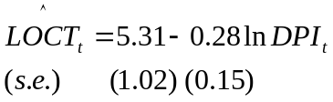

(a) (5 marks) □ Perform t-tests for significance of both coefficients of the model.

□ Give interpretation to both coefficients.

(b) (5 marks) □ In the equation above, there is no information about the R-square. Is it possible to restore its value from the available information?

□ Is R-square high enough to make the equation significant?

(c) (5 marks) At the seminar one of the participants remarked that coefficient of 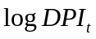 is expected to be negative as people tend to use personal cars instead of local transport as their income rises. The other participant objected to him saying that just the opposite is true (the coefficient of should be positive) as local transport is used mainly by elderly people who prefer not to use cars and are quite sensitive to changes in income.

□ How both suggestions change your conclusion on significance of the coefficients of the model?

Answering all questions state clearly null and alternative hypotheses, degrees of freedom, used critical values.

Question 2 Recently, the Central Bank of Russian Federation revoked the licenses of several Russian banks, some other banks are considered as problematic and some of them are at risk of revocation of license in the near future. In this connection customers and entrepreneurs are interested in the estimating the state of the bank to select reliable banks. Preliminary expert analysis showed that such variables can be useful:
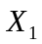 - percentage of the amount in foreign currency liabilities in the balance sheet of the bank;
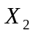 - share of total loans in the amount of operating assets, and
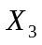 - the ratio of the balance sheet profit to balance losses.
A survey was conducted of 100 largest banks (in terms of value of liabilities and capital), which resulted in the following data: (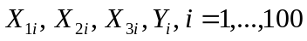), where 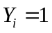, if the Central Bank attributes this bank to the category of problematic banks, and 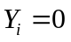 otherwise. Suppose you are invited as a consultant to build the regression model as a function of 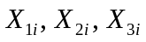.

(a) (5 marks) □ Explain why linear regression model 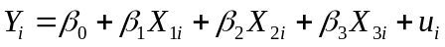 estimated using OLS is not appropriate in this case. Give some mathematical details.

(b) (5 marks) □ Explain why probit model can solve some problems indicated in (a) providing the rationale of the proposed form of the function, and explaining why the obtained estimates have acceptable econometric properties.

□ How to estimate that some factor, say, 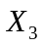, is significant on the basis of the proposed model?

□ How to estimate that a group of factors, for example, 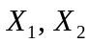, is significant on the basis of the same model?

(c) (5 marks) Suppose some characteristic, say has changed while maintaining other explanatory variables unchanged.

□ How to evaluate the effect of this change on the probability of revocation of license in the near future?

□ Is it possible to evaluate maximum marginal effect of some factor, say (while keeping fixed)? How to find the value of , which provides this maximum, considering known?

Question 3 Let the multiple linear regression equation be

(a) (5 marks) □ Outline briefly, how you would test 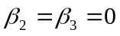.

□ Outline briefly, how you would test 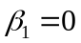.

(b) (5 marks) □ Outline briefly, how you would test 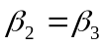.
□ Outline briefly, how you would test against one-sided alternative 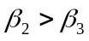

(c) (5 marks) □ What assumptions are necessary to all of these tests were valid.

Question 4. Suppose that the time series 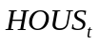 (Housing), 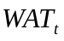 (Water), 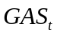 (Gas), 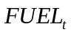 (Fuel oil), 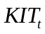 (Kitchen appliances), 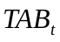 (Tableware) form the panel (as observations for particular units of some general type of good (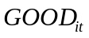) related to maintaining a home). 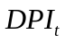 is the disposable personal income and  is the relative price index for corresponding . 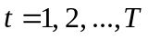, 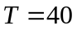, 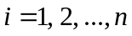, 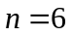
Let the model under investigation be
;
The student runs three alternative approaches to the evaluation of this model: 1) pooled OLS regression, 2) fixed effects panel regression model, and 3) random effects panel regression model.

(a) (5 marks) □ Help the student to choose between different approaches: fixed effects panel regression model, and random effects panel regression model. Indicate corresponding test, null hypothesis, type of distribution of the test statistic, the number of degrees of freedom and the decision rule (which alternative is chosen if null hypothesis is rejected and which if it is not).

□ What are advantages and risks of each choice?

(b) (5 marks) Any model of panel data is based on the assumption that unobserved heterogeneity is present in the data under consideration.
□ Explain what is unobserved heterogeneity, describing general structure of the panel data model.

□ How to test whether there is a significant difference between pooled regression and separate regressions?

□ How to test for the presence of unobserved heterogeneity if random effect model was chosen in (a)?

(c) (5 marks) □ How to test for the presence of unobserved heterogeneity if fixed effect model was chosen in (a)? Give some details for the test statistic, degrees of freedom and used critical values. Do the test and make the conclusion.

SECTION В
(1 hour 10 minutes + 10 minutes for reading)
Answer TWO questions from this section (questions 5-7).
Each answered question in this section bears 20 marks.

Question 5. A researcher is considering the following alternative regression models for the expenditures on tobacco 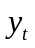 (in billions of euro) subject to the relative price index of tobacco 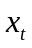 using annual data (1990-2013 - 24 observations) for Germany:
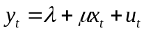 (1)
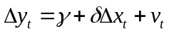 (2)
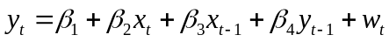 (3)
where 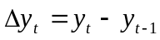, 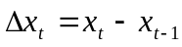, and 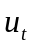, 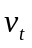, and 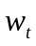 are disturbance terms.

He obtained the following results estimating these equations
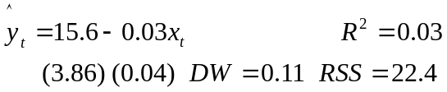 (1’)
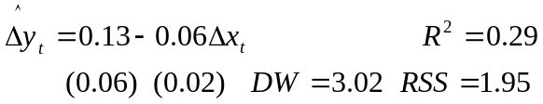 (2’)
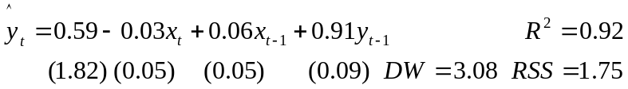 (3’)

(a) (5 marks) □ Test the first equation for autocorrelation.

□ Test the second equation for autocorrelation.

□ Test the third equation for autocorrelation.

(b) (5 marks) To test the model (1) for autocorrelation using Common Factor Test the researcher estimated the restricted version of the equation (3) using the restriction 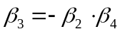
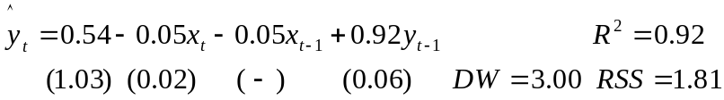 (3R’)

□ Show that equation (1) under assumption of the first order autocorrelation 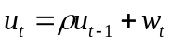 can be transormed into equation
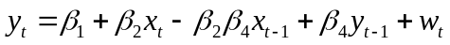 (3R)
what is restricted version of equation (3) under restriction .

□ Explain the logic of Common Factor Test? Do Common Factor test, giving test statistic and decision rule.

□ What is your conclusion? What is interpretation of the coefficinent 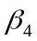 of the variable 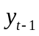 in (3R)?

(c) (5 marks) Let (1) is the correct specification and w_{t} satisfies the Gauss-Markov conditions. Taking into account your conclusions in a)

□ Explain what problems, if any, would be encountered if ordinary least squares were used to fit (1) ?

□ Explain what problems, if any, would be encountered if ordinary least squares were used to fit (2) ?

□ Explain what problems, if any, would be encountered if ordinary least squares were used to fit (3) ?

(d) (5 marks) □ Show that (1) and (2) are restricted versions of (3), what are the restrictions?

□ Test these restrictions? Which of these tests could be done using both 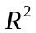 and 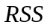 and which can be done using only one of these indicators?

Question 6. A researcher is considering the following alternative regression models for the expenditures on tobacco (in billions of euro) subject to the relative price index of tobacco using annual data (1990-2013 - 24 observations) for Germany:
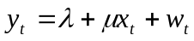 (1)

(2)

where , , and , , and are disturbance terms.
He got the following results of the estimation of these equations
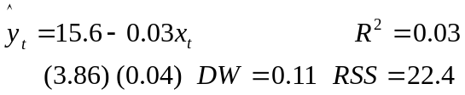 (1’)
(2’)

(a) (5 marks) The colleague advised the researcher to check the data series for stationarity by telling him about the computer (Monte Carlo) experiments of Newbold-Granger, and said that his estimated regression (1') is spurious regression.
□ What is covariance stationarity, why is it important in econometrics?

□ What is the Monte Carlo experiment? What are Newbold-Granger's experiments, what are their most important results?

The researcher argued that the equation (1') is insignificant, so the conclusions of the experiments of Newbold-Granger cannot be applied to it, and therefore, regression (1') is not spurious.

□ Who is right in assessing equation (1') with respect to the property 'spurious' – the researcher or his colleague?

(b) (5 marks) The researcher decided to test the data series for stationarity by constructing the following Dickey-Fuller equations
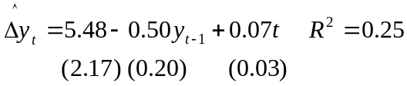 (3’) 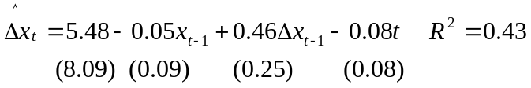 (5’)

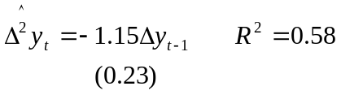 (4’) 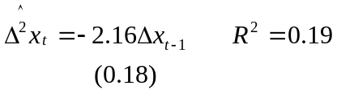 (6’)

□ Interpret the results of the evaluation of Dickey-Fuller equations. Which of the time series are stationary and which are non-stationary?

□ What is the difference between the specification of equation (3') and the specification of equation (5'), does each of these specifications have any advantages?

□ What does "best specification" in the Dickey-Fuller equation mean? On what basis can one choose the best specification of the equation?

(c) (5 marks) Explore Dickey-Fuller equation models (3) and (5) mathematically, explaining the logic of Dickey-Fuller test.
□ Derive theoretical model corresponding time series model (3’). Give null and alternative hypothesis and decision rule.
□ Derive theoretical Dickey-Fuller equation model corresponding time series model (5’).

(d) (5 marks) The researcher noticed that the chaotic dynamics of relative tobacco prices reminds both random walk and negative autocorrelation, and decided to use for modeling an equation
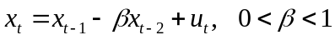 (7),
where 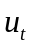 has zero mean 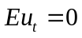, constant variance 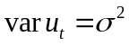and not correlated with 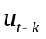 and 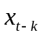, 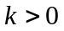.
□ Help the researcher to decide whether this time series is stationary or non-stationary
Hint: Use difference Dickey-Fuller equation to explore time series.
Question 7.
A researcher is considering the following alternative regression models for the expenditures on tobacco (in billions of dollars) subject to the relative price index of tobacco using annual data (1971-2015 - 45 observations) this time for USA:
(1)
(2)
where , , and , , and are disturbance terms.
He got the following results of the estimation of these equations
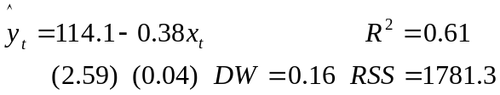 (1’)
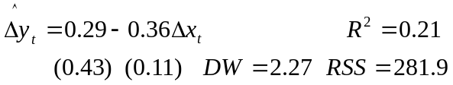 (2’)

(a) (5 marks) You are given that the time series and are difference stationary, or they are integrated of order 1: 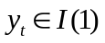, 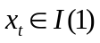 .

□ Explain what does it mean that time series is difference stationary and trend stationary.

□ Give the examples of difference stationary and trend stationary time series. Show that the time series you have given posess the specified properties.

□ What is the main difference between two types of time series under consideration.

(b) (5 marks) □ What is cointegration? How to test whether time series and are cointegrated (you are given again that , .

□ What are relative advantages and disadvantages of the models (1) and (2)?

Let 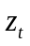 are residuals of equation (1’). To test them for stationarity the researcher runs the regression
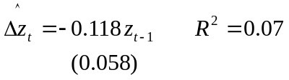
□ What is the meaning of this equation? What is your conclusion from the test (use the following critical values for ADF t-statistic 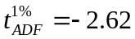, 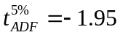, 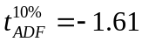)?

(с) (5 marks) Consider a simple 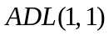 model
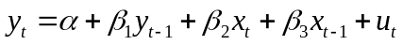 (3)

□ Derive error correction model based on (3).

(d) (5 marks) Let model (4’) is the result of estimation error correction model, obtained in (c) for years 1960-1996
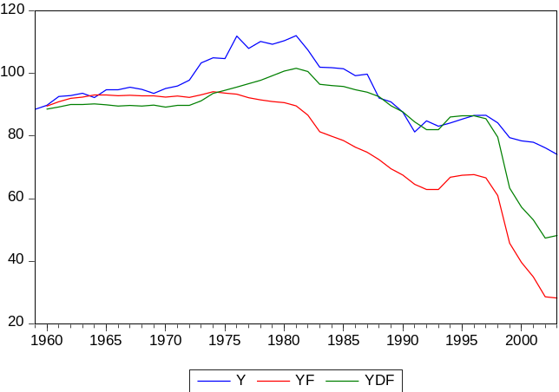 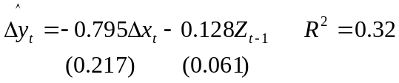 (4’)

□ Give interpretation to the estimated model. Explain how error correction mechanism works.

Let variable 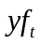 be forecast obtained using by error correction model and 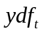 be forecast obtained using difference model (2).

□ Comment the following graph, demonstrating predictive power of different models

